<https://smu365-my.sharepoint.com/:w:/g/personal/hpurdom_smu_edu/ERYSgNE7LTBGgxpbwS6ErK8BKTHiF9hjFdvSHkEKbFC7oQ?e=un68qC>

From Syllabus

***Paper Draft Zero*** – Draft Zero is meant to provide an early checkpoint:

- to force teams to be formed,

- to force the teams to identify a problem or problem domain,

- to force the teams to find one or more advisors, and

- to force the teams to begin the process of defining and understanding the problem they are about to solve.

Writing is the primary method used to both document and refine the problem statement and the work performed. Draft Zero begins that documentation.

Note that Draft Zero is exactly that, the very first beginnings of the paper that will become your Capstone paper published in the SMU Data Science Review-Journal. This draft, and all drafts, should be written as a draft in the template for your final paper. Include only the material that will be included in your final paper. Do not include information on timelines, milestones, project plans, etc. None of that information will be in your final paper, so do not include it in any of your drafts. If you do wish to include notes, timelines, or any other information that either may not or will not be in your final paper, create one or more Appendices and place the material in there. Do not reference Appendices from the main body of your paper.

*Draft Zero is expected to be at least five pages in length, including the draft title, author list (include all advisors as authors in the list), abstract draft, the Introduction section (including but limited to one paragraph motivation and one paragraph problem statement) and a background section (literature review).* (Page count does not include reference page).

1. Teams are expected to have performed a related work and tutorial topic search.
2. The literature review should have at least ten (10) different peer-reviewed research studies cited. Draft Zero will have a reference section in APA format.
3. A preliminary set of sections with their titles should be created to indicate the general and expected flow of the paper. This is particularly important for you to identify the tutorial sections required to ensure that the general audience reader will be able to understand your work.
4. All citations should be correctly used (citations are always contained within the same sentence that they are citing, i.e., the citations come before the period ending the sentence – preferably right next to the words needing to be cited). Plagiarism in Draft Zero will result in a grade of ‘F’ for the course and a referral to the SMU Honors Council for an Honor Code violation.
5. ***All drafts should not include we/our or project. This is a research paper. Use terms such as “this paper, this study or this research”.***

There is no maximum page limit on your final paper; however, all papers are expected to be at least fifteen (15) pages in length, excluding any appendices, in their final form. All papers are expected to have at least twenty (20) references (10 of which are peer-reviewed) in their final form. These may sound like huge numbers now, but they are actually very small numbers in practice. Very few teams have difficulties reaching these minimum requirements, and those that do have difficulty have that difficulty because they choose to fight the requirements instead of embracing them. As you move forward in your documentation, keep these final lengths and reference requirements in mind. You will have no difficulty in reaching them if you are diligent in your documentation and your problem solution.

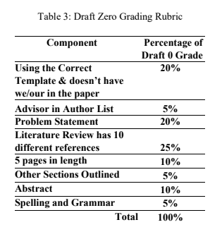

***\*\*If there are no in-text citations and/or reference list in APA format then grade will automatically be a zero.***

From Slides

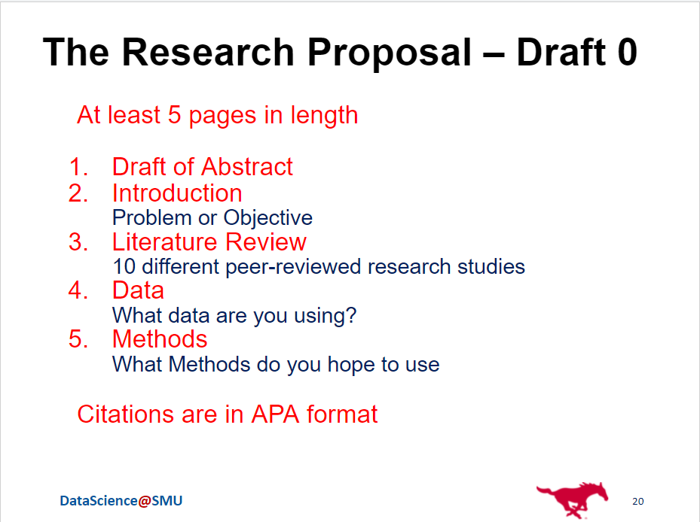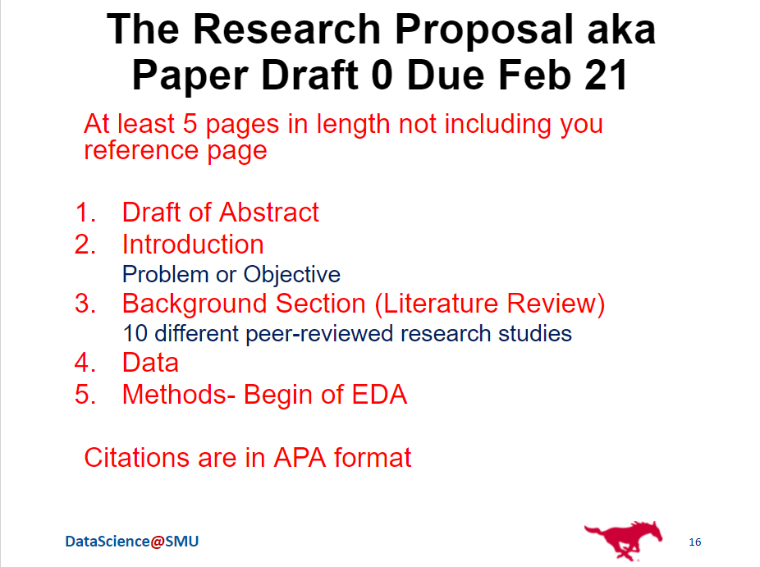

Plan of Action

1. Background Section (Lit Review)
   1. +5 peer reviewed sources (about 2 each)
   2. More understanding of current sources - add to chat which sources you are looking into
   3. Piece together in a flow that works
      1. Example:
         1. Particle Collisions
         2. Particle Tracking
         3. Particle Tracking Algorithms
         4. Related Work (?)
2. Data
   1. Explaining our dataset
   2. Data description
3. Methods
   1. Beginning of EDA

Friday - use teams chat to send what progress has been made, plan meeting for Sat or Sun